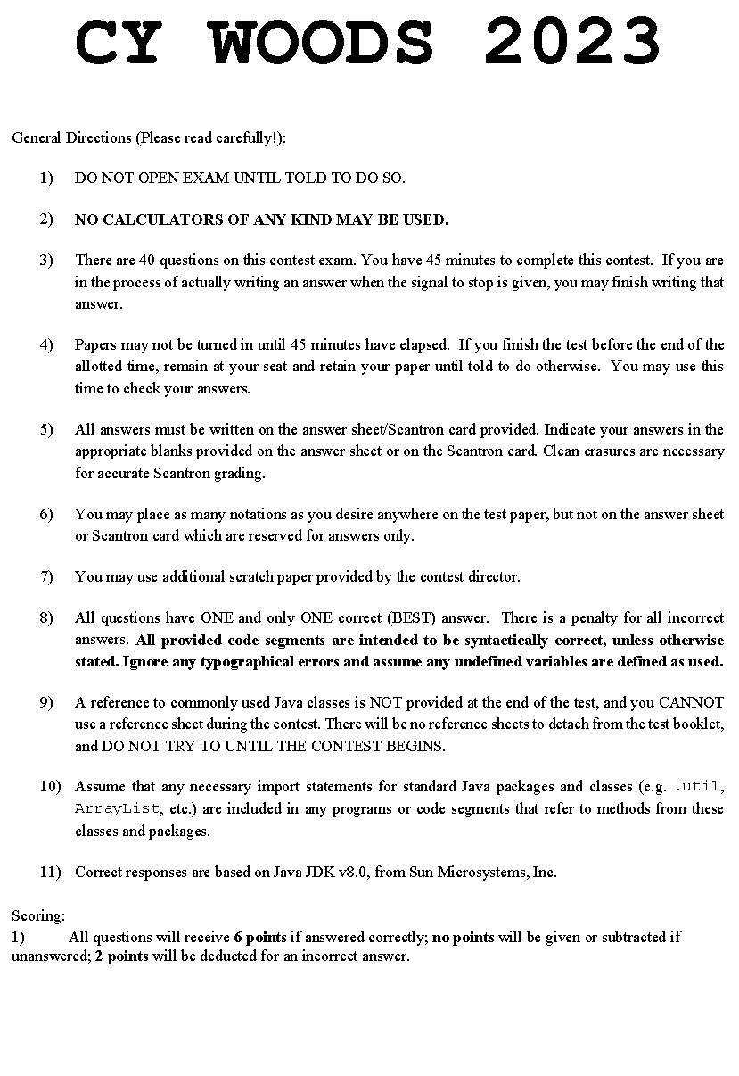

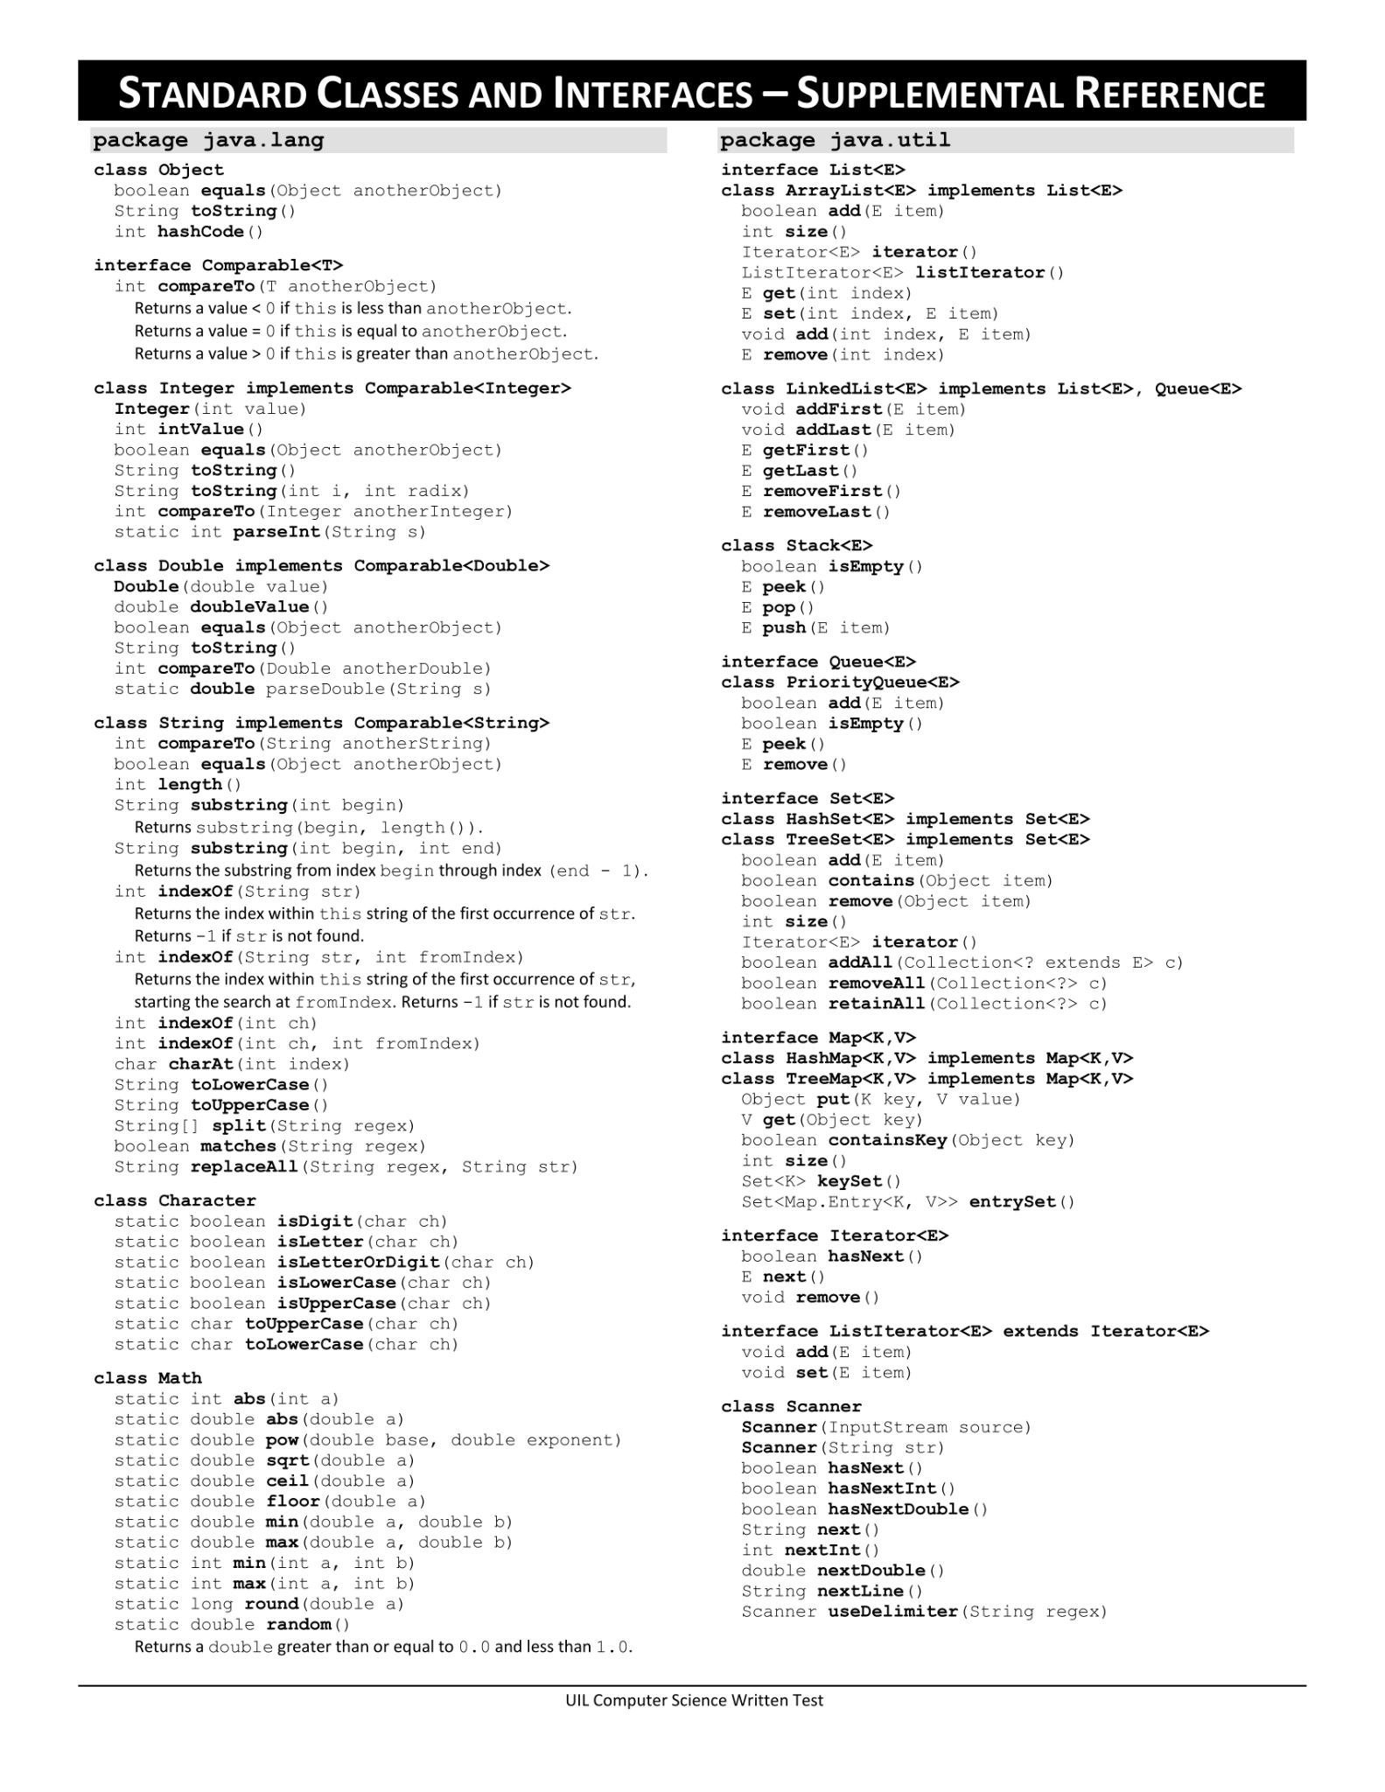

| **CY-WOODS WRITTEN TEST** |
| --- |

| **Note:** Correct responses are based on **Java SE Development Kit 20 (JDK 20)** from Sun Microsystems, Inc. All provided code segments are intended to be syntactically correct, unless otherwise stated (e.g., “error” is an answer choice) and any necessary Java SE 8 Standard Packages have been imported. Ignore any typographical errors and assume any undefined variables are defined as used. **For all output statements, assume that the System class has been statically imported using: import static java.lang.System.*;** |
| --- |

| Question 1xxx  Which of the following is equivalent to 348 + 4A16?  **A)** 111001112 **B)** 1214 **C)**  9210 **D)** 2506 **E)** 6416 | |
| --- | --- |
| Question 2xxx  What is output by the code segment to the right?  **A)** -44.5  **B)** 45  **C)** 22  **D)** -45  **E)** No output due to an error. | out.print(9 * -5 + 1 / 2); |
| Question 3xxx  What is output by the code segment to the right? **A)** Woo **B)** woo  **C)** WOODS **D)** Woods  **E)** woods | out.printf("%3s", "Woods"); |
| Question 4xxx  What is output by the code segment to the right?  **A)** 4Jimmy24  **B)** 13Jimmy13  **C)** 4Jimmy13 **D)** 13Jimmy1234  **E)** 4Jimmy12 | out.print(1 + 3 + "Jimmy" + 1 + 2); |
| Question 5xxx  What is output by the code segment to the right?  **A)** true **B)** false | boolean t = false, f = true;  out.print(t && !f || t || f && t); |
| Question 6xxx  What is output by the code segment to the right?  **A)** 87  **B)** 88  **C)** 119  **D)** 120  **E)** 5S | char kerrett = 'S';  out.print(5 + kerrett); |
| Question 7xxx  What is output by the code segment to the right?  **A)** -11 **B)** 12  **C)** 11 **D)** -12  **E)** 0 | String a = "hengle";  String b = "henry";  out.print(a.compareTo(b)); |
| Question 8xxx  What is output by the code segment to the right?  **A)** [1, 2, 1] **B)** [1, 3, 2]   **C)** [1, 2, 3] **D)** [1, 2, 0, 1]  **E)** No output due to a runtime error. | ArrayList<Integer> al = new ArrayList<>();  al.add(1);  al.add(2);  al.add(2, 1);  out.println(al); |
| Question 9xxx  What is output by the code segment to the right? **A)** true **B)** false  **C)** True **D)** False  **E)** No output due to an error. | float a = 0;  double b = 0.0f;  out.println(a == b); |
| Question 10xxx  What is output by the code segment to the right?  **A)** 7  **B)** Yay 6  **C)** Yay 7 **D)** 6  **E)** No output due to a syntax error | int simon = 6;  if (simon > 6) {  out.println("Yay");  simon++;  }  out.println(simon); |
| Question 11xxx  What is output by the code segment to the right?  **A)** ABC  **B)** [A, B, C]  **C)** ABE **D)** [A, B, E]  **E)** Output cannot be determined until runtime. | char[] john = {'A', 'B', 'C'};  char[] ohan = john;  ohan[2] = 'E';  out.print(john); |
| Question 12xxx  What is output by the code segment to the right?  **A)** 18  **B)** 35  **C)** 36  **D)** 56  **E)** 57 | int tot = 1;  for (int i = 1; i < 9; i++) {  for (int j = i; j < 7; j++) {  tot += i % j;  }  }  out.println(tot); |
| Question 13xxx  What is the order of precedence for the operations on the right form the highest precedence to lowest precedence?  **A)** III, IV, I, II  **B)** II, III, IV, I  **C)** II, I, IV, III  **D)** IV, III, I, II  **E)** II, I, III, IV | 1. << (shift) 2. () (cast) 3. == (equality) 4. | (bitwise OR) |
| Question 14xxx  What is output by the code segment to the right?  **A)** [Apple, Cherry, Date]  **B)** [Banana, Cherry, Date]  **C)** [Apple, Banana, Cherry] **D)** [Banana]  **E)** There is no output due to a syntax error | List<String> a = new ArrayList<>();  a.add("Apple");  a.add("Banana");  a.add("Cherry");  a.add("Date");  a.removeIf(fruit -> fruit.startsWith("B"));  out.println(a); |
| Question 15xxx  What is output by the code segment to the right?  **A)** {garry=2, henny=4, bowey=3, hengle=1}  **B)** {bowey=3, henny=4, garry=3, hengle=1}  **C)** {bowey=3, garry=3, hengle=1, henny=4}  **D)** {hengle=1, garry=3, bowey=1, henny=4}  **E)** {bowey=3, garry=3, henny=1, hengle=4} | Map<String, Integer> map;  map = new TreeMap<String, Integer>();  String[] line = "bowey henny garry bowey henny garry bowey hengle garry henny henny".split(" ");  for (String s : line) {  map.putIfAbsent(s, 0);  map.put(s, map.get(s)+1);  }  out.println(map); |
| Question 16xxx  What is output by the code segment to the right? **A)** 5 5 **B)** 12 12  **C)** 5 12 **D)** 12 5  **E)** No output due to a runtime runtime error | public class Nikki {  int bowen;  public Nikki (int l) {  bowen = l;  }  public String toString() {  return bowen + "";  }  }  public class Poo extends Nikki {  int bowen;  public Poo (int l) {  super(5);  bowen = l;  }  public String toString() {  return bowen + "";  }  }  //client code  Nikki bru = new Poo(12);  out.print(bru + " " + bru.bowen); |
| Question 17xxx  What is output by the code segment to the right?  **A)** 4  **B)** 8  **C)** 12 **D)** There is no output due to a syntax error.  **E)** There is no output due to a runtime error. | out.println(Double.SIZE / Double.BYTES); |
| Question 18xxx  What is output by the code segment to the right?  **A)** -3  **B)** -4  **C)** -3.0 **D)** -4.0  **E)** -3.50 | out.print(Math.round(-3.5)); |
| Question 19xxx  What is output by the code segment to the right?  **A)** 29  **B)** 31  **C)** 56  **D)** 83  **E)** 85 | int sum = 2;  for (int i = 0; i <= 9; i+=4) {  for (int j = 0; j <= 4; j+=2) {  for (int k = 0; k <= 7; k+=3) {  sum+=j;  }  }  }  out.print(sum); |
| Question 20xxx  What of these could be an output by the code segment to the right?  **A)** 2  **B)** 4  **C)** 5  **D)** A and B only  **E)** A, B, and C | out.println((int) (Math.random() * 3) + 2); |
| Question 21xxx  What is output by the code segment to the right?  **A)** 2  **B)** 4  **C)** There is no output due to a syntax error.  **D)** There is no output due to a compile error.  **E)** Output cannot be determined due to an infinite loop. | int a = 550;  int b = 0;  while(500 > b) {  a -= 10;  b *= 2;  }  out.println(a + " " + b); |
| Question 22xxx  What is output by the code segment to the right?  **A)** A1 **B)** A2  **C)** AB3 **D)** AB1  **E)** AB2 | int b = 1;  if (b == 1 || ++b > 1) {  out.print("A");  }  if (b == 1 | b++ > 3) {  out.print("B");  }  out.print(b); |
| Question 23xxx  What is the worst time complexity of inserting an element into an arraylist?  **A)** O(1) **B)** O(n) **C)** O(log(n)) **D)** O(nlog(n)) **E)** O(n^2) | |
| Question 24xxx  What is output by the code segment to the right?  **A)** [HENGLE, LEO, LEON, b0wenator, bowen]  **B)** [HENGLE, LEO, LEON]  **C)** [HENGLE, LEO, b0wenator, LEON, bowen] **D)** [HENGLE, LEO, b0wenator, bowen, LEON]  **E)** No output due to a compile error. | PriorityQueue<String> pq;  pq = new PriorityQueue<>();  pq.add("b0wenator");  pq.add("bowen");  pq.stream();  pq.add("LEON");  pq.add("50 Cent");  pq.poll();  pq.add("Kerrett");  pq.remove();  pq.add("LEO");  pq.add("HENGLE");  pq.remove("50 Cent");  out.println(pq); |
| Question 25xxx  Which line causes an error?  **A)** line 1  **B)** line 2  **C)** line 3  **D)** line 4  **E)** There is no error | ArrayList avatar;  avatar = new ArrayList<String>(); //line 1  avatar.add("John");  avatar.add(321.31231); //line 2  avatar.add("Hello"); //line 3  out.println(avatar.add("A")); //line 4 |
| Question 26xxx  What is output by the code segment to the right?  **A)** yd  **B)** dy  **C)** ht  **D)** th  **E)** No output due to a compile error | public String recur(String str) {  if (str.length() <= 2)  return str;  String s = "";  if (str.length() % 2 == 0) {  for (int i=1; i < str.length(); i+=2)  s += str.charAt(i);  }  else {  for (int i=0; i < str.length(); i+=2)  s += str.charAt(i);  }  return recur(s);  }  /////////////CLIENT CODE/////////////////////  out.println(recur("henryisstupid")); |
| Question 27xxx  What is output by the code segment to the right?  **A)** 21  **B)** 36  **C)** 34  **D)** 29  **E)** 24 | int[] a = {5, 12, 6, 15};  out.println(a[1]+a[2] * 2); |
| Question 28xxx  What is output by the code segment to the right?  **A)** [51, 90, 0, 4]  **B)** [4, 0, 51, 90]  **C)** [9, 51, 0, 23]  **D)** [90, 51, 0, 4]  **E)** No output due to syntax error. | LinkedList<Integer> hengle;  hengle = new LinkedList<>();  hengle.push(51);  hengle.push(90);  hengle.addFirst(9);  hengle.add(23);  hengle.addLast(4);  hengle.pop();  hengle.set(2, 0);  hengle.peek();  out.println(hengle); |
| Question 29xxx  What is output by the code segment to the right?  **A)** [45, 32, 90]  **B)** [32, 45, 90]  **C)** [32, 45, 45, 90]  **D)** false  **E)** true | Set<Integer> tree = new TreeSet<>();  tree.add(45);  tree.add(32);  tree.add(90);  out.println(tree.add(45)); |
| Question 30xxx  What is the simplified boolean algebra identity that is on the right?  **A)** A  **B)** B+A  **C)** A*B  **D)** A*A + A*B  **E)** A^2 + A*B | A*(A+B) |
| Question 31xxx  What is output by the code segment to the right?  **A)** 0 **B)** 6  **C)** 9 **D)** 54  **E)** No output due to a compile error | int bi = 54;  bi = bi % 6;  out.println(bi); |
| Question 32xxx  What replaces **<*1>** in the code to the right to make the sort  function correctly?  **A)** new int[]{0, arr.length, 0}  **B)** new int[]{0, arr.length() - 1, 0}  **C)** new int[]{0, arr.length - 1, 0} **D)** new int[]{0, arr.length / 2, 0}  **E)** new int[]{0, arr.length / 2 + 1, 0} | public class Structure {  public int[] arr;  public Queue<Integer> q;  public Structure(int[] data) {  this.arr = data;  this.q = new LinkedList<>();  }  public void transform() {  Stack<int[]> s = new Stack<>();  s.push**(<*1>**);  while (!s.isEmpty()) {  int[] top = s.pop();  int a = top[0];  int c = top[1];  int stage = top[2];  if (a < c) {  int m = (a + c) / 2;  if (stage == 0) {  s.push(new int[]{a,c,1});  s.push(new   int[]{m+1,c,0});  s.push(new int[]{a,m,0});  } else {  search(a, m, c);  }  }  }  }  public void search(int s, int m, int e) {  int i = s;  int j = m + 1;  while (i <= m && j <= e) {  if (arr[i] > arr[j]) {  q.add(arr[i++]);  } else {  q.add(arr[j++]);  }  }  while (i <= m) {  q.add(arr[i++]);  }  while (j <= e) {  q.add(arr[j++]);  }  int k = s;  while (!q.isEmpty()) {  arr[k++] = q.remove();  }  }  } |
| Question 33xxx  Assume that **<*1>** is filled out correctly. What is the output of the client code below?  int[] data = {23, 5, 1, 0, 100, 99};  Structure s = new Structure(data);  s.transform();  out.println(Arrays.toString(data));  **A)** [100, 99, 23, 5, 1, 0]  **B)** [99, 100, 0, 1, 5, 23]  **C)** [23, 5, 1, 0, 100, 99] **D)** [0, 1, 5, 23, 99, 100]  **E)** No output due to a compile error |
| Question 34xxx  What is the average time complexity of the sorting algorithm demonstrated on the right?  **A)** O(n)  **B)** O(n log(n))  **C)** O(n^2) **D)** O(log(n))  **E)** O(n+k) |
| Question 35xxx  What type of sort does the Structure class implement?  **A)** Tree Sort  **B)** Radix Sort  **C)** Heap Sort  **D)** Merge Sort  **E)** Quick Sort |
| Question 36xxx  What is output by the code segment to the right?  **A)** 0 **B)**8  **C)** 16 **D)** 25  **E)** 42 | out.print(23 ^ 7 | 5 << 3 & 3 % 2); |
| Question 37xxx  What is output by the code segment to the right? **A)** %lol **B)** lol  **C)** % **D)** bob  **E)** 8lol | String[] a = "* 8 bob t 5 % lol".split(" ");  Iterator <String> it;  it = Arrays.stream(a).iterator();  it.next();  while(it.hasNext()) {  if(it.next().matches("\\W"))  out.print(it.next());  } |
| Question 38xxx  What is output by the code segment to the right?  **A)** [, j, , , hn, hanl, n]  **B)** [j, , , hn, hanl, n, , ]  **C)** [, j, , , , hn, hanl, n, , ] **D)** [, j, , hn, hanl, n]  **E)** [, j, , , ,hn, hanl, n] | String[] ar = "ojooohnohanlonoo".split("o");  out.println(Arrays.toString(ar)); |
| Question 39xxx  What is the value of the postfix expression shown below. Assume its decimal division.  5 4 * 10 / 2 32 + 7 9 * 3 - + + | |
| Question 40xxx  What is the lowest cost to go from Node B to Node H on the graph below? | |